RED CLAY POW WOW
OCTOBER 28 AND 29, 2017 (School Day 27th)
Red Clay State Park, Cleveland, TN
Contact 423-240-7270 or 423-478-0339

Hosted by Friends of Red Clay www.FriendsofRedClay.org
Co-Hosted by Native American Services of TN www.naservices.org
ADMISSION $5 donation per car Sat/Sun
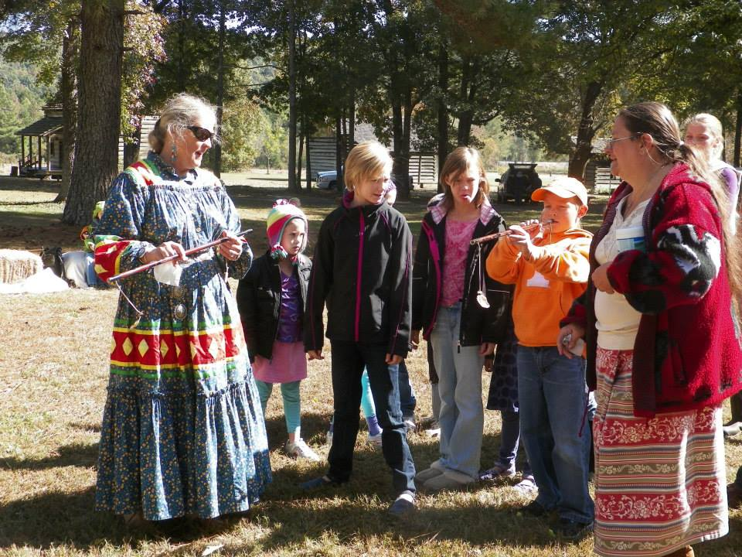
Handicap accessible
Friday (schools) 9am-3pm (reservations required)
Special Programs all day $5.00 per child
Saturday 10am-Dusk Grand Entry 1pm
Sunday 10am-5pm Grand Entry 1pm
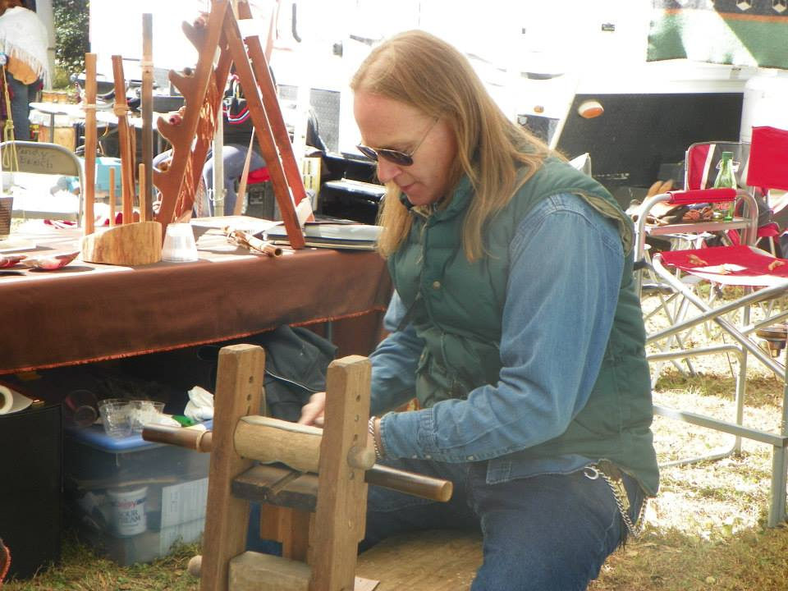
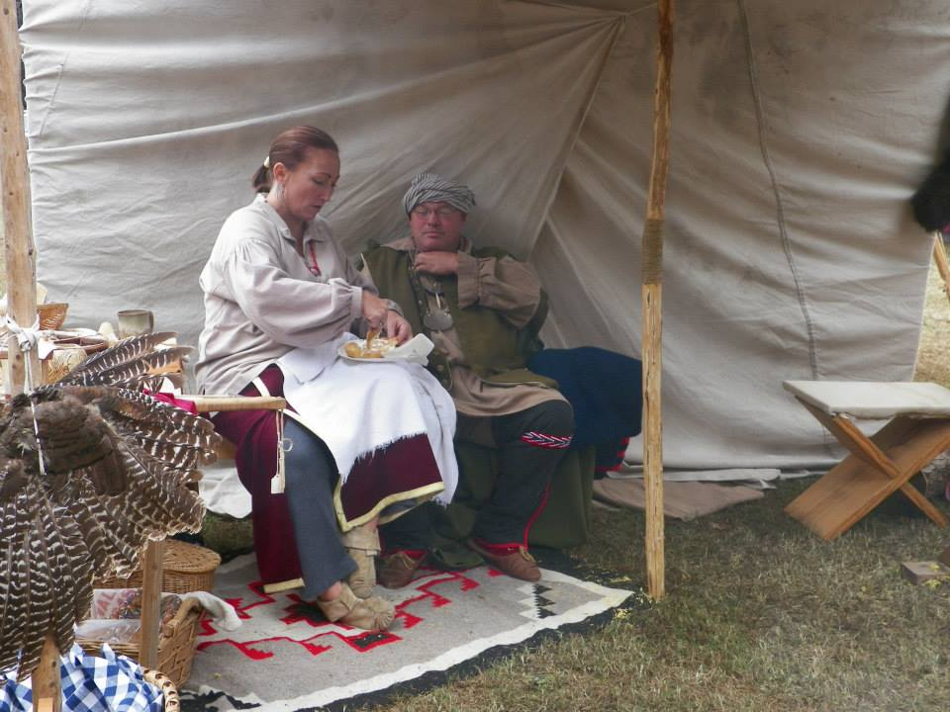

FIRST TIME………..$$$$$ CONTEST POW WOW $$$$$
$$$$$ CHICKEN DANCE, TEEN JINGLE AND FANCY SHAWL DANCE SPECIALS $$$$$
$$$$DRUM AND HAND DRUM CONTEST$$$$ SPEND THE WEEKEND WITH US AT
All VENDORS welcome-applications on listed websites RED CLAY STATE PARK….
Primitive Camping-no showers/electricity SEE NATIVE AMERICAN DANCERS, VISIT
Self Contained RV’s welcome CRAFT BOOTHS, SHARE STORIES, ENJOY THE
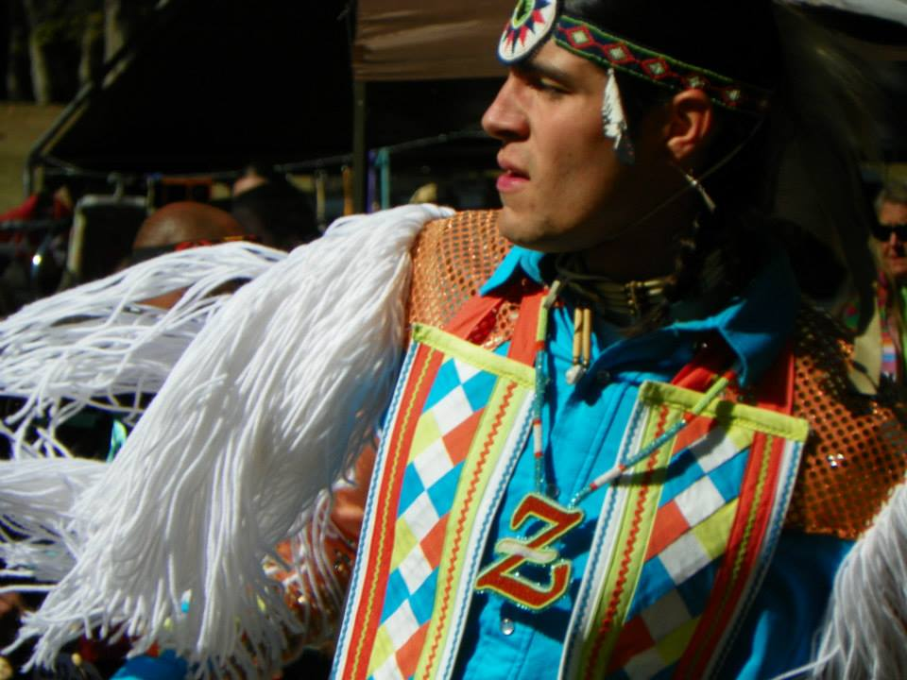
PRIMITIVE ENCAMPMENTS AND LIVING
HISTORY SITES AND THE ENTERTAINMENT

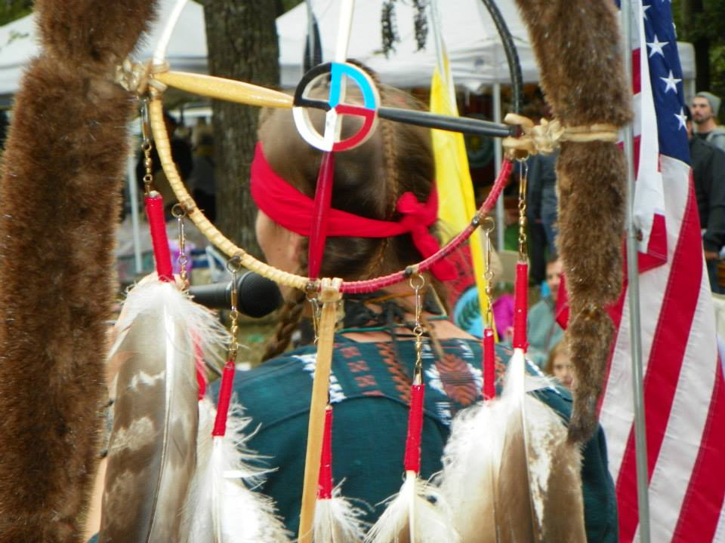
Host Hotel:
Quality Inn, 153 James Asbury Dr., NW
Cleveland, TN 37312 423-478-5265
Additional housing:
Applegate Inn, 1857 APD 40, Cleveland, TN 423-479-9915

1140 RED CLAY PARK ROAD, SW, CLEVELAND, TN 37311 HTTP//TNSTATEPARKS.COM/REDCLAY

